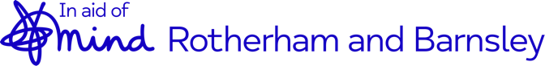
Sponsorship Form

R B Mind are an independent charity within the Rotherham & Barnsley Boroughs. Although affiliated with national Mind we are responsible for our own fundraising. We work with all ages across the boroughs from 7 up to adults.

Name of participant
Event
Name | Address |  | Post Code (essential for Gift Aid) | Amount | Paid?  Y / N | Gift Aid

Name | Address | Post Code (essential for Gift Aid) | Amount | Paid?  Y / N | Gift Aid

Thank you for your help and contributions!

Important Please Read

If you tick yes to gift aiding your donation, please ensure that you read and understand the following:

I am a UK taxpayer and understand that if I pay less Income Tax and/or Capital Gains Tax in the current tax year than the amount of Gift Aid claimed on all my donations, it is my responsibility to pay any difference.

Please notify us if you want to cancel this declaration, change your name or home address or if you no longer pay sufficient tax on your income and/or capital gains.

If you prefer you can also donate online, by visiting our website or social media pages:
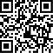
https://www.rbmind.co.uk/get-involved/donate/
www.facebook.com/rotherhamandbarnsleymind/
https://twitter.com/rmbymind
https://cafdonate.cafonline.org/6309#!/DonationDetails#%2FDonationDetails

